Data issue: Inconsistency with the vehicle probe data – on several probes, the location of the probes is described in three ways: with a freeform text label, with placement on a map, and with lat and long coordinates. The map location (that is, the probe’s placement on a digital map display within the and lat/long coordinates are consistent, but the text label does not match. To help verify which data is correct, we looked at actual probe data, for those probes with the conflicting info, and compared that in real-time to Google map’s traffic feature. The results consistently show that the map locations and lat/long attributes of the probes are correct; the text labels are wrong.

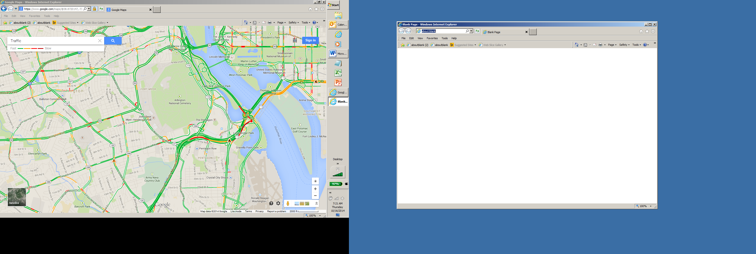

Figure 1. Google maps at 7:20am, 10/16/14.

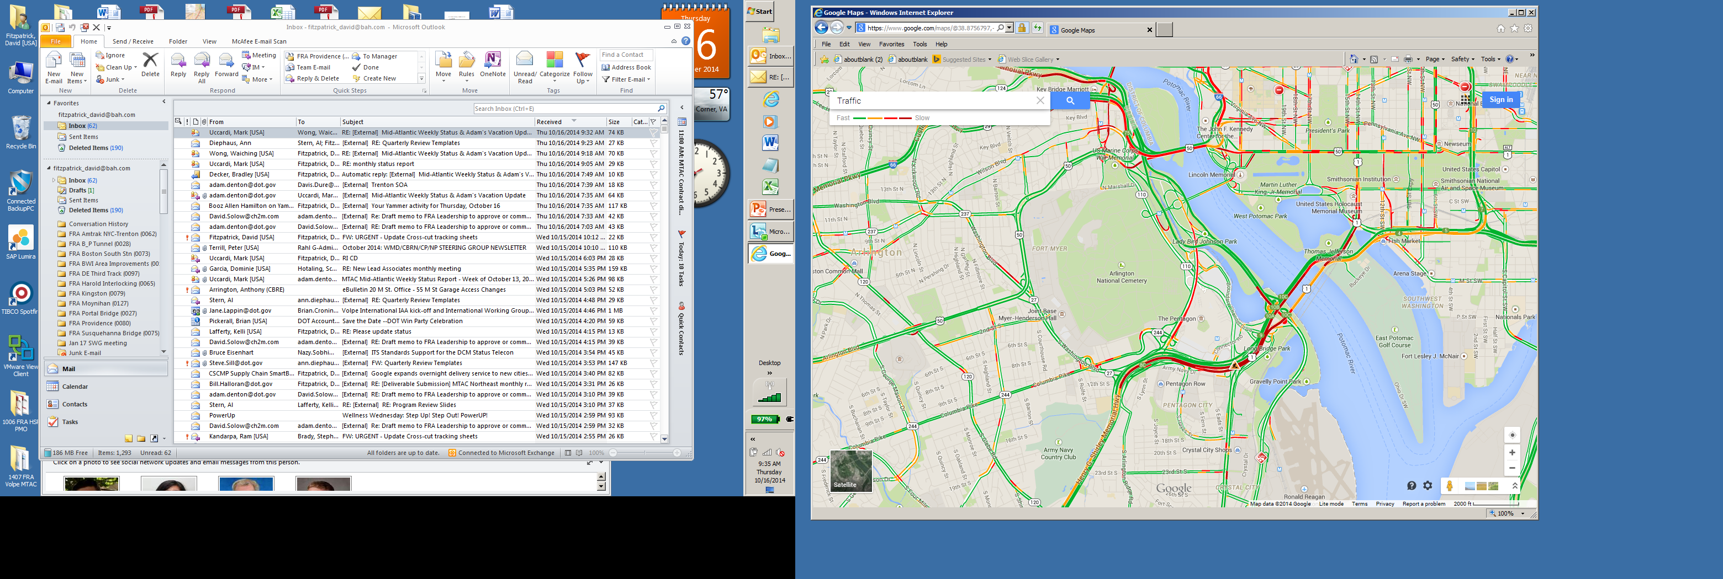

Figure 2. Google maps at 9:30am, 10/16/14.

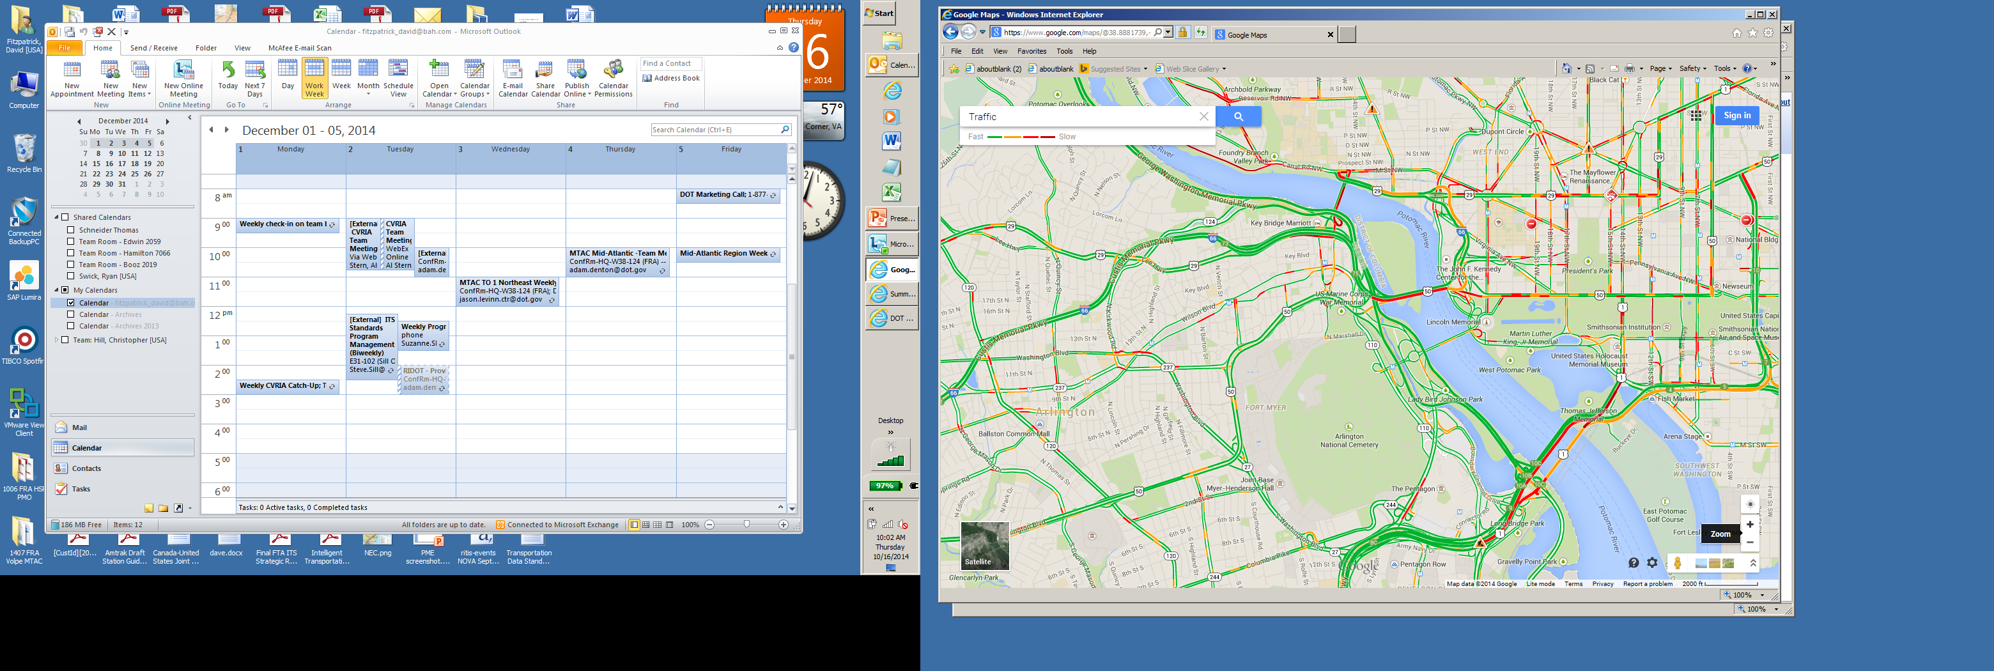

Figure . Google maps at 10:00am, 10/16/14.

**TMC 110+05757**

RITIS map shows: inbound Memorial Bridge

Label says: “Ohio Dr., Eastbound”

Google shows:

7:20 – all green

9:30 – 70% yellow; 30% green

10:00 – 50% yellow; 50% green

VPP data extract shows:

7:20 – 36mph actual vs 36mph reference speed

9:30 – 23mph actual vs 36 mph ref

9:50 – 25mph actual vs 36 ref

Conclusion: Google data matches to the map placement on RITIS. As Ohio Drive seemed all green at all times, this label seems inaccurate.

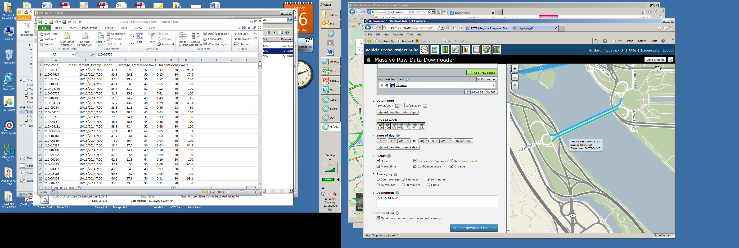

**TMC 110-05756**

RITIS map and label show road segments that were both green during the test times. Google shows speeds of at least 30mph (against reference speed of 34mph). Cannot draw any conclusions.

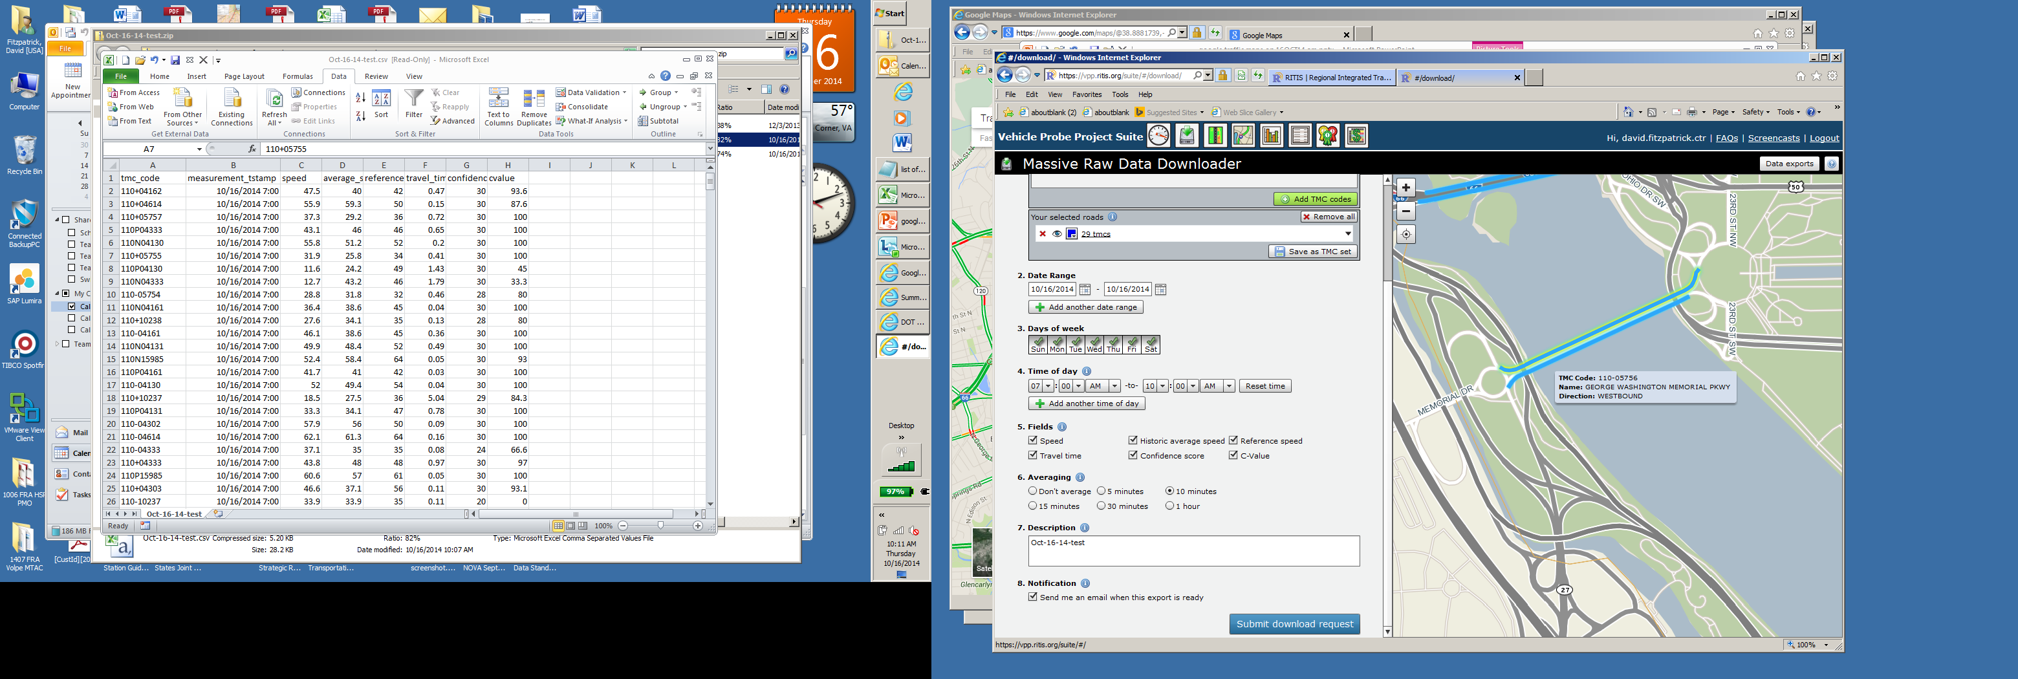

**TMC 110+05755**

RITIS map shows this as the inbound Key Bridge

Label says: “Whitehurst Fwy”

Google shows: (I only looked at it for the 10am reading)

10:00 – all red

VPP data extract shows:

9:50am – 7mph vs 34mph reference speed

Note that the Whitehurst Fwy is showing as all green in both directions.

Conclusion: Google data matches to the map placement on RITIS. Label seems inaccurate.

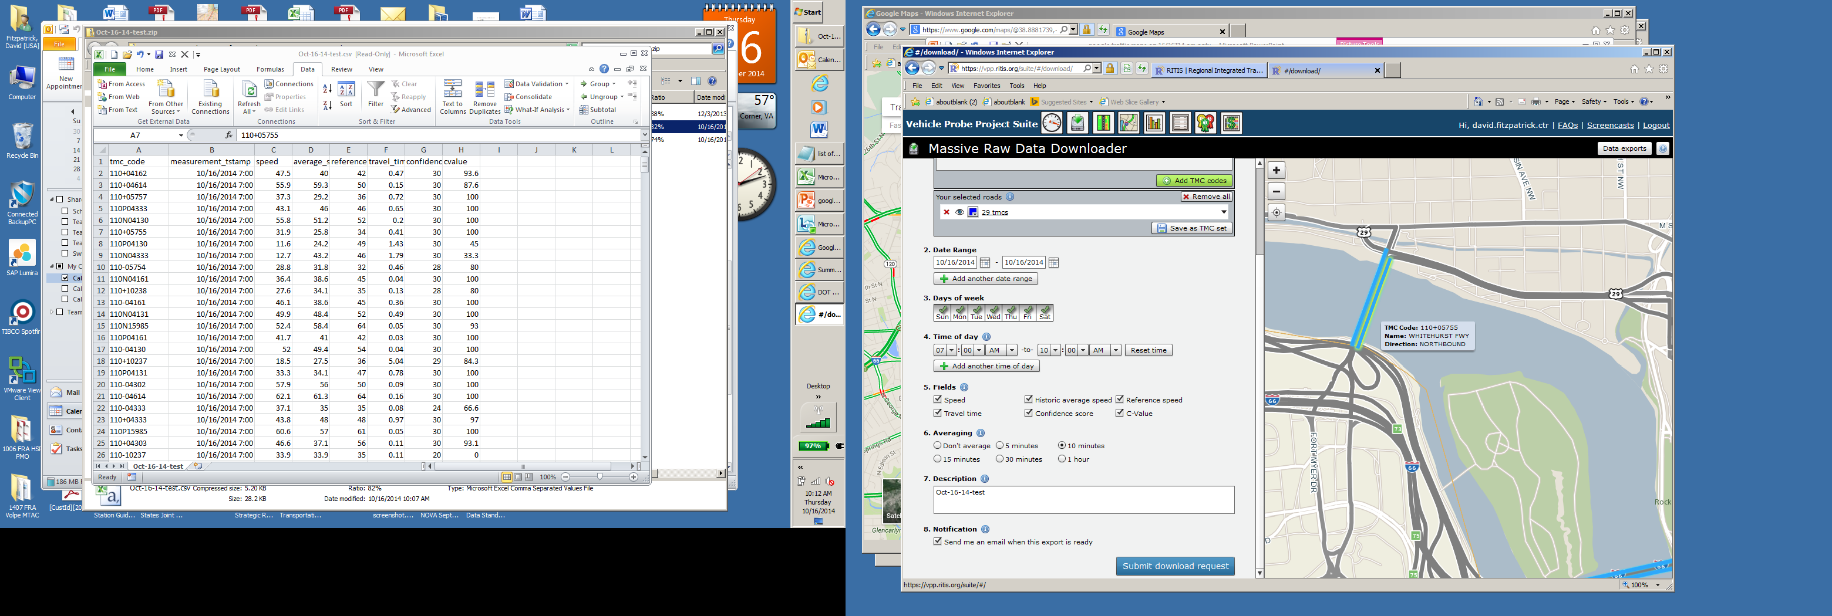

**TMC 110+04333**

RITIS map shows this as GW Parkway northbound

Label says: I-395/US-1 Northbound

Google shows:

7:20am – I-395 is red for about ½ mile prior to the 14th St Bridge; GW Pkwy is mostly green, brief segment of yellow

9:30am – I-395 is red for over 1 mile prior to the 14th St Bridge; GW Parkway is green with a ¼ mile segment of red.

10:00am – I-395 is red for about ¼ mile prior to the 14th St Bridge; GW Pkwy is green over most of its length.

VPP data extract shows:

7:20 – 47mph actual vs 48mph reference speed

9:30 – 38mph actual vs 48 mph ref

9:50 – 49mph actual vs 48 mph ref

Speeds seem close to free flow, which is much closer to the actual conditions on the GW Parkway.

Conclusion: The map is accurate, the label is not.